

**UNIVERSITI KUALA LUMPUR**

**Where Knowledge Is Applied**

**SCM PROPOSAL**

|  |  |
| --- | --- |
| **CAMPUS** | MALAYSIAN INSTITUTE OF INFORMATION TECHNOLOGY |
| **COURSE CODE** | ISB42303 |
| **COURSE NAME** | SOFTWARE CONFIGURATION MANAGEMENT |
| **GROUP** | L01 |
| **STUDENT NAME/ID** | MUHAMAD ARIF BIN FAHROL RODZI  (52213116168)  AIMAN BIN AHMAD BUKHARI  (52213217111)  AINA NADHIRAH BINTI HASBOLLAH (52213116119)  MUHAMMAD FIRDAUS BIN MOHD JOHARI  (52213217065) |
| **YEAR/SEMESTER** | JULY 2019 |
| **COMPANY LOGO** |  |

**INTRODUCTION**

Computers have become a way of life for today’s high society. Many aspects of modern life that we have come to accept as common place would not be possible if there were no computers. Today computers are use extensively in many areas of business, industry, science, education etc.

The major advantage of computer is its speed that makes it able to give some useful information very quickly. This speed also opens new approaches to problem solving and data processing. Another feature is its accuracy. Though the computers do only what is instructed at every instant, these instructions are taken into account and accurate informations are produced. Computer can hold data and instruction in an electronic representation in internal memory and this data can be retrieved at any time

The project entitled “Cyber Café Management System” is a software package, which can be used in cyber cafés for managing the equipment provided efficiently. Nowadays, having a cyber café without proper management system calls for disaster. Thereby, it is indeed necessary to store the valid information of the user who comes for internet access. The system being used, the time at which the user logs in and logs out should be recorded systematically.

**PROBLEM STATEMENT**

Presently, most of the functions in the Cyber Global Sdn. Bhd. cyber cafe are done manually. The owner records the details of the clients, login and logout time, cabin and has to calculate the amount manually on paper. Also, there is no special system to allocate cabins efficiently. The owner also has to manually calculate the total income of a day. The present system has following limitations:

* Limitations in report generations
* Manual recording consumes excess time
* Chances of human error
* Difficulty in allocating cabins
* The retrieval of information regarding a client is time consuming
* Lack of billing system and manual calculation of daily income
* Repeated recording of frequent user details

Focusing on the drawbacks and inadequacies of the existing system, the new system is designed which could well replace the existing system.

**AIM AND OBJECTIVES**

**Aim:** To develop a secured and reliable cyber café management system

**Objectives:**

1. To identify management issues related to cyber café utilities and its users
2. To design a work space where the cyber café owners can easily view, add and edit information regarding its customers and utilities
3. To develop an automated cyber café software that include provision of user details and login history while helping the café owner in calculating daily usage of the systems and income.

**SCOPE OF THE PROJECT**

In this day and age, a number of people access the internet frequently by means through cyber cafes. For such frequent users, a prepaid account shall be needed and discounted rates may be charged to them. While walkthrough users, who are less frequent, are charged a fixed rate. This system comprises of the following modules:

**• Computer Module:** This module shall store computer information and the user shall be able to edit or add new computers accordingly.

**• The Report Module:** This module shall be able to generate a report to be displayed on the system

**• Admin Module:** This module shall be able to access every customer detail and generate fees for the customer

* **Search Module**: This module shall be able to search for customer details through customer’s name or ID number.

**METHODOLOGY**

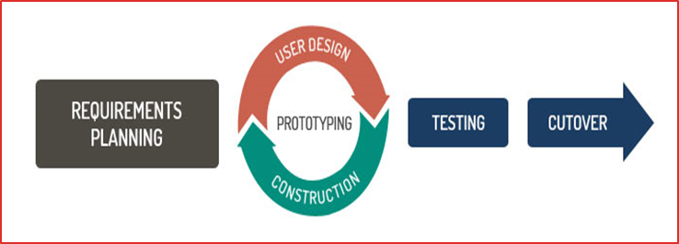

**Rapid application design model (RAD)**

**Stage 1: Requirement Planning**

This step in the RAD model takes information gathered through interviews from staff and visitors of the Cyber Global Sdn. Bhd. cyber café. We will also be referring to similar project and find a way to improve and adapt it to be used in this project.

**Stage 2: User Design**

During this stage, all the information gathered during the requirement, planning phase is analysed. Through the analysis, the information is grouped together into different group that can be useful to the project. The quality of every of information is carefully examined and given an accurate description. A relationship between these groups and their usefulness as defined in the requirements planning step is also established during this phase of the RAD model. During this stage, state changes and optimizations can be done and sets of data can be further defined. Any description for adding, removing, or changing the data objects are also created during this phase. Later, database, use case and algorithm design are produced.

**Stage 3: Construction**

The construction phase is the step in the RAD model procedure where the designs form user Design phase are converted into the actual program. All the information gathered is developed and coded into actual prototypes that can be tested in the next step.

**Stage 4: Testing**

This stage allows for a reduced time in the overall testing of the prototype created. Every model is tested individually so that components can be quickly be identified and switched in order to create the most effective product. By this point, most of the components have already been examined, so major problems with the prototype are not likely. The testing technique that will be used is dynamic testing which contains both white box and black box method. The white box method is used at Requirement Planning phase to make sure all the requirements are met.

**Stage 5: Cutover**

After testing, the mobile application may be delivered to the client if there are no flaws or defects that needs to be fixed. If there are any, the project needs to be revised back and go back to the User Design phase.

**RESOURCE LIST**

|  |  |  |
| --- | --- | --- |
| Item | Quantity | Price |
| Hardware:   * 8GB DDR4 RAM * 128GB SSD + 1TB HDD * Intel Core i7 * Windows 10 | **1** | **RM4497** |
| Software:   * PHP * Xampp * NetBeans 8.0 | **1** | **n/a** |
| Configuration Management System:   * GitHub Desktop | **1** | **n/a** |

**CONCLUSION**

In conclusion, the system shall be able to provide a convenient and systematic approach in managing cyber café utilities and its customers by having a search function, report generation function and computer utilities form.